Lab Task 01
Zain jabbar (323)
AI (lab)
Q:1
Create a timeline containing at least five AI milestones, including one AI-winter period and one modern compute/data milestone. Arrange entries chronologically. For each, give the year or period, event, a one-sentence explanation of its significance and a source. Include the required AI-winter period and a modern compute/data milestone. Put the timeline in your .docx report; this remains a historical evidence task, not a model-training exercise.
What I did
1. `timeline` stores AI history years and events as a list of tuples.
2. The `for` loop takes each tuple and assigns its values to `year` and `event`.
3. `print(year, "-", event)` displays the year and event with a dash between them.
4. The code is valid Python and should run without errors.
5. If indentation or quotation marks are incorrect, you may get an `IndentationError` or `SyntaxError`.
Code screenshot
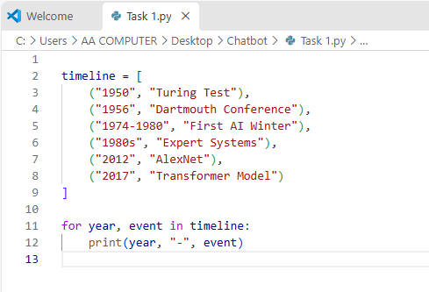
Code Explanation
This code stores AI history dates and events in a list called `timeline`.
Each entry is a tuple containing a year and an event name.
The `for` loop goes through each tuple one at a time.
For each tuple, it assigns the year to `year` and the event name to `event`.
The `print` statement displays them like: `1950 - Turing Test`.
Code Run Screenshot
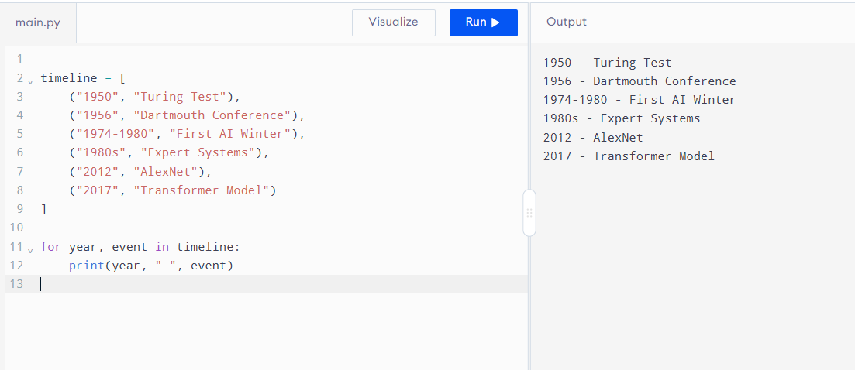
Q:2
Modify the rule-based example with two additional transparent conditions and test four cases. Retain score >= 70 and document completeness, then add two explicit, named conditions of your choice. State that thresholds are synthetic lab assumptions. Prepare exactly four core test cases covering a pass, failure of each new condition, and a threshold boundary. Print the input, expected result, actual result and reason for every case; explain how you selected them.
What I did
1. The `check` function returns `True` only if the score is at least 70, completeness is at least 80, citations are available, and the source is reliable.
2. The `tests` list contains four sets of values to check.
3. `enumerate(tests, 1)` numbers each test starting from 1, while `check(*test)` passes the values into the function.
4. The code is valid Python and should run without errors.
5. It prints: Case 1: PASS, Case 2: FAIL, Case 3: FAIL, and Case 4: FAIL.
Code Screenshot
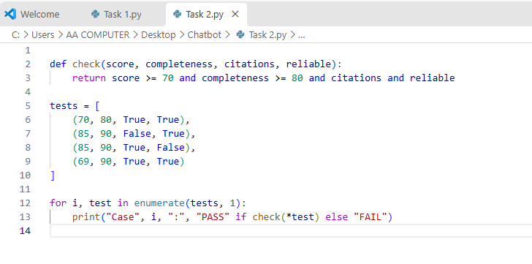
Code Explanation
The `check` function tests whether the score is at least 70, completeness is at least 80, citations are available, and the source is reliable.
The `tests` list contains four sets of values to check.
The loop goes through each test and numbers them starting from 1.
`check(*test)` passes each set of values to the `check` function.
The program prints `PASS` if all conditions are met; otherwise, it prints `FAIL`.
Code Running Screeshot
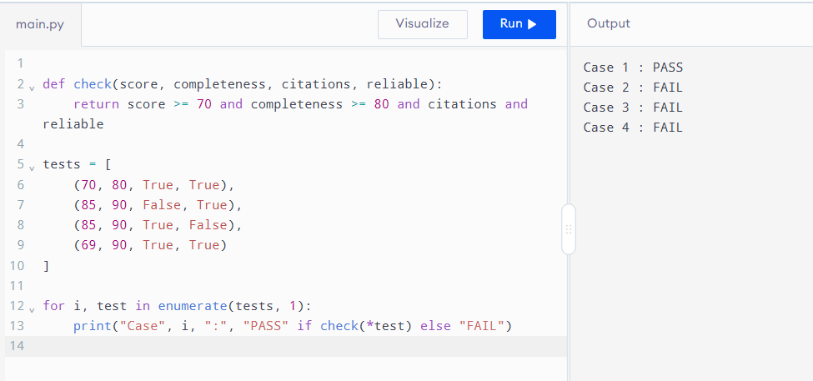
Question 3
Write a short comparison explaining why passing a conversational test is not the same as proving general intelligence. Write a focused comparison in your report using the scholarship case. Explain what the conversational test observes, what it does not establish, and one example of fluent but incorrect reasoning. Conclude with one additional test of reliable task performance; support historical claims with sources.
What I did
1. This code is valid Python and should run without errors.
2. It prints a comparison between conversational tests and general intelligence.
3. It explains that passing a conversation test does not prove true understanding or reliable reasoning.
4. It gives an example of incorrect mathematical reasoning and suggests other ways to evaluate AI.
5. It ends with a historical claim about Alan Turing’s imitation game and its source link.
Code Screenshot
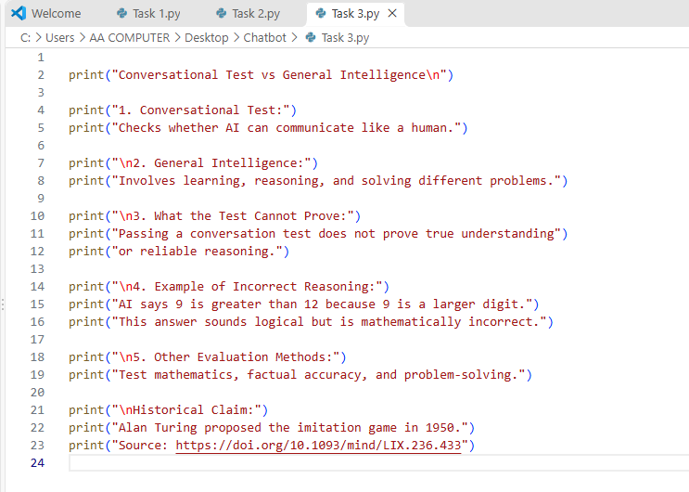
Code Explanation
This code prints a short explanation comparing conversational tests with general intelligence.
It describes what a conversational test checks and what general intelligence involves.
It explains that passing a conversation test does not prove an AI truly understands or reasons reliably.
It gives an example of incorrect reasoning and lists other ways to evaluate AI.
Finally, it states that Alan Turing proposed the imitation game in 1950 and prints a source link.
Code Running Screeshot
